MYOPIA CONTROL
Myopia (nearsightedness) is a condition that causes poor distance vision without spectacle correction. This is most commonly caused by increasing axial length of the eye (length from front to back). As children are growing, often their eyes are growing longer. This can cause a child’s nearsighted spectacle prescription (amount of myopia) to increase at a high rate over time.
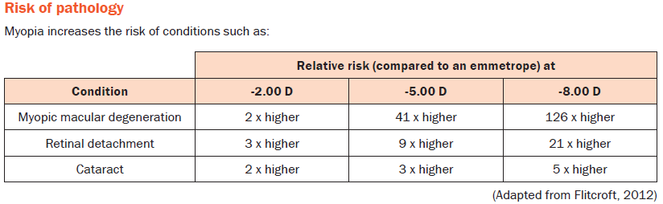
A child’s risk of high myopia is increased if they become myopic (nearsighted) at a young age. Aside from poorer vision, high myopia can be sight-threatening due to the much higher risk for eye disease. Myopia is becoming a large public health risk around the world: It is estimated that by 2050, myopia will affect 50% of the world’s population and 10% of the world’s population will have high myopia¹.
Myopia Control is a newer field of Optometry which uses different types of glasses, contact lenses, or eye drops to help slow down the year-to-year increase in prescription (myopia). Myopia Control does NOT completely stop progression of myopia, but it can slow progression by 25-60%. This reduction can be life-changing in preventing a person from sight-threatening consequences of high myopia. Myopia control is well-supported by peer-reviewed studies.
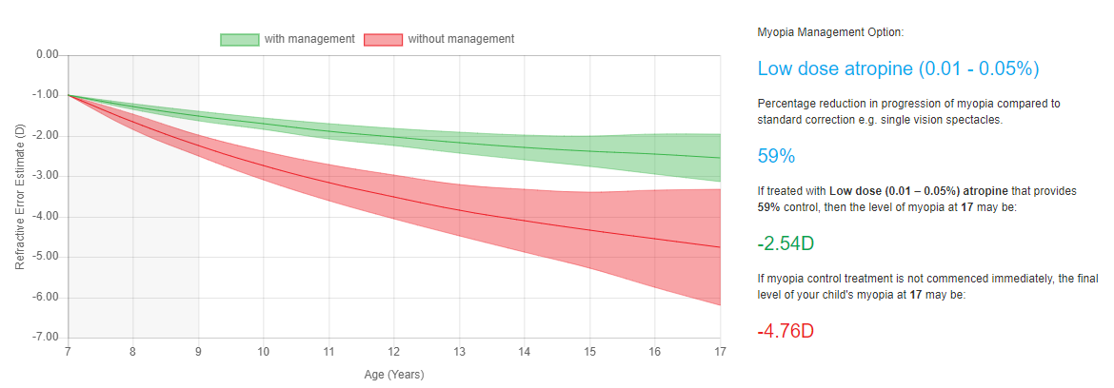
An example of a child’s expected myopia progression with myopia control (green) as opposed to regular correction without myopia control (red).
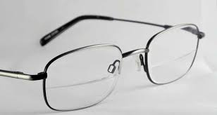
Types of Myopia Control
Executive Bifocal Glasses: average reduction in myopia progression 39-51%²
These are glasses with a traditional lined bifocal which goes across the whole lens. These glasses are great for small children who cannot yet tolerate contact lenses or eye drops. These glasses are also good for children who need astigmatism correction as part of their prescription.
Multifocal Soft Contact Lenses: average reduction in myopia progression 25-72%^{3, 4}
Multifocal Contact lenses are useful for children who are old enough to handle contact lens wear and children who do not want to wear spectacles full-time. These contact lenses feature special optics that focus the center of the child’s vision for distance and ‘normal’ viewing, while the outside edges (periphery) of their vision is focused to help with near vision. This effect helps reduce the peripheral vision signals that are thought to contribute to worsening of myopia. These contact lenses are effective and comfortable; however, they are not very effective at correcting astigmatism. They also can cause some peripheral blurriness, but many children adapt to this quickly.

Low-dose Atropine Eye Drops: average reduction in myopia progression 59%⁵
Atropine eye drops have been used for decades to slow down myopia. In higher concentrations (1.0%), Atropine drops are used to dilate the eyes and relax the eyes’ focusing muscles. In this ultra-low concentration (0.01%), Atropine drops can help to mildly relax the child’s focusing system to prevent it from working harder than it needs to, which can help slow down myopia. Children still need to wear glasses or contact lenses while using Atropine eye drops. There is a potential for some mild side effects such as light sensitivity while using these drops, but they are generally easily addressed. Another benefit of Atropine eye drops is that they can be used in combination with other myopia control methods (like bifocal glasses or multifocal contact lenses) to increase the myopia-slowing effect.
Frequently Asked Questions about Myopia and Myopia Control:
- What can I do to limit my child’s risk of myopia (nearsightedness)?
  - Some studies show that not enough outdoors time and too much indoor near work (reading, tablet/electronic device use) significantly increases risk for becoming nearsighted (myopic).
- If I am nearsighted, what is the chance my child will be too?
  - Having one parent with myopia increases the child’s risk by 2 times. Having both parents with myopia increases the child’s risk by SIX times! Having 2 parents with myopia also increases a child’s risk of having fast-progressing myopia.
- Can eye exercises slow down or fix my child’s nearsightedness?
  - Vision therapy (‘eye exercises’) is a very useful field in eye care. However, Vision Therapy is not useful for myopia. It is more effective for eye conditions that cause problems with eye turns or eyes not working together. Glasses prescription itself cannot be fixed with any type of eye exercises.
- Will wearing glasses make my child’s vision worse?
  - No! Actually, studies find that the opposite is true: Your child is more likely to progress at a faster rate if they go uncorrected than if they are wearing their correct glasses prescription. Going without proper correction only hurts your child’s performance in school and makes things worse.
- Will myopia control stop my child’s glasses prescription from getting worse?
  - No. Myopia control helps to slow down progression, but some progression is still expected. Each child’s case is different and requires a personalized treatment plan to get the best myopia-slowing effect possible.
- My child is very young. Is it safe to use myopia control on them?
  - Yes. The younger a child is when they become nearsighted (myopic), the higher their risk for having high myopia if we do not try to control it. Dr. Armitage will help to devise a treatment strategy that is both effective and age-appropriate for your child.
- How long will my child have to do myopia control?
  - Each case is different. If myopia progression in your child slows to almost nothing, sometimes we can wean off the therapy to see if it stops progressing permanently. Myopia control is not intended to last forever.

- Holden BA, Fricke TR, et al. 2016. “Global Prevalence of Myopia and High Myopia and Temporal Trends from 2000 through 2050”. Ophthalmology 123(5): 1036-1042.
- Cheng D, et al. 2014. “Effect of bifocal and prismatic bifocal spectacles on myopia progression in children: three-year results of a randomized clinical trial”. JAMA Ophthalmol 132(3): 258-264.
- Aller TA, Wildsoet C. 2006. “Results of a one-year prospective clinical trial (CONTROL) of the use of bifocal soft contact lenses to control myopia progression.” Ophthal Physiol Opt 26(6).
- Anstice NS, Phillips JR. 2011. “Effect of dual-focus soft contact lens wear on axial myopia progression in children”. Ophthalmology 118(6): 1152-1161.
- Chia A, et al. 2016. “Five-year clinical trial on atropine for the treatment of myopia 2: Myopia control with Atropine 0.01% eye drops.” Ophthalmology 123(2): 391-399.

